[ production title]
ALBERT TOOLKIT Guidance summary

Key to all things ALBERT: START EARLY! The sooner you get started, the sooner you will know what data you need to gather, and what measures can be taken to reduce the footprint of the production.
Use this document alongside our sustainability guidelines and your own initiative in order to make the production as sustainable as possible, to drive positive change and also to save money - the smaller the footprint, the less it will cost to offset the emissions. Please keep a folder of all evidence and take photos.
Here’s a link to a video from ALBERT on how to use the calculator: https://www.youtube.com/watch?v=Vl6tpZK8UvI
In early prep do the following:
- review albert calculator to identify what data is needed and decide how to gather it
- send memos to the relevant crew members about what data you want them to collect
- go through the budget with your accountant to signpost what needs to be tagged
- group together costs within the budget, where possible, to make tagging easier
- create a budget code in your budget template for carbon offset costs
- talk to your main suppliers and get commitment for emissions reductions and to provide data
In prep you should complete a draft footprint and carbon action plan, and after wrap finalise what you can.

Carbon Footprint
Below is a summary of what data needed to complete the albert calculator, how you can collect the data, actions you can take to reduce emissions in each category, and space for notes when drafting the footprint.

Non filming Spaces
What | Energy use (electricity, gas, generator) in:  - production offices  - workshops  - post-production offices  - home offices
How | - Check how energy is tracked/billed for your rented spaces  - Take readings at start and end, if metered  - Talk to landlords about tracking energy if not metered (or failing that use the benchmark)  - Have your accountant tag in accounting program, if invoiced separately
Actions | - Encourage landlords to switch to renewable energy and install LED lights / bulbs
Draft / Final | - Use benchmarks or budgeted allowances for the draft footprint  - Make notes here about the data needed for the final footprint:

Filming Spaces
What | Energy (electricity, gas) in studio and fuel (petrol, diesel, LPG, biofuel, propane) used for generators, heating, SFX, cooking etc on set/at base  - studio and  - location
How | - Have your accountant tag in accounting program - final data needed for this section would be best sourced from accounts  - Take readings if metered
Actions | - Ask studio and main location landlords to switch to renewable energy and install LED lights / bulbs  - Access mains power where possible  - Ask your facilities, lighting, catering companies to use HVO instead of diesel in generators  - Secure your supply of HVO  - Ensure you use only generators of stage 3a and above as minimum standard  - Use electric generator for any overnight needs  - Avoid leaving devices plugged in overnight  - Speak to your camera team about using LED lights on set  - Avoid space heaters where possible
Draft / Final | - Use benchmarks or budgeted allowances for the draft footprint  - Make notes here about the data needed for the final footprint:

Travel
What | Travel and deliveries paid for from the budget, measured by distance, spend or fuel used  - Air travel (commercial, charter, helicopter)  - Road travel (car, coach/minibus, motorcycle, truck/van, HGV, taxi)  - Rail  - Boats  - Couriers & excess baggage (air, motorcycle, truck/van)  - Freight (train, sea tanker, cargo ship)
How | - Have your accountant tag in accounting program (splitting, fuel and mileage and other journeys where fuel is not directly charged)  - Use Travel coordinator tracker
Actions | - Source crew, goods and services locally wherever possible to reduce travel & shipping  - Use video conferencing to reduce travel  - Avoid and reduce flying where possible  - Make it a rule to have no domestic flights on your production  - Where it is necessary to fly, choose economy  - Use trains where possible  - Use electric vehicles where possible, including taxi services  - Use green delivery services and speak to your suppliers (equipment, construction, props etc) about using green delivery companies  - Ask your facilities, lighting, catering companies to use HVO instead of diesel in road engines  - For unit drivers, minibuses and crew with diesel cars/vans who charge fuel to production, encourage them to fill up with HVO  - Choose accommodation close to filming locations
Draft Final | - Use budgeted allowances for the draft footprint  - Make notes here about the data needed for the final footprint:

Accommodation
What | Energy estimated for accommodation used on the production, measured by numbers of room/nights, split into these categories  - Economy Hotel – 1–2 star hotel  - Midscale Hotel – 3 stars  - Upscale Hotel – 4 stars  - Luxury Hotel – 5+ stars  - Apartment / Condo / Flat  - Average House  - Large House
How | - Have your accountant tag in accounting program  - Use Travel coordinator tracker
Actions | - Ask hotels & landlords for their environmental policies, and encourage them to switch to renewable energy and install LED lights / bulbs
Draft / Final | - Use budgeted allowances for the draft footprint  - Make notes here about the data needed for the final footprint:

Materials
What | New materials used on the production including  - Batteries  - Cardboard (in weight or dimensions)  - Food (split into vegetarian, vegan, fish, chicken, pork, lamp, beef)  - Glass (in weight or quantity)  - Metal (in weight or quantity)  - Paint (matt/gloss/water-based in litres)  - Paper  - Plastics (in weight or quantity)  - Textiles (in weight or dimensions)  - Timber (in dimensions or spend)
How | - This is one of the hardest sections, as productions don’t already track materials (unlike travel/fuel/accommodation which are tracked) – rely on estimates as necessary rather than leaving blank  - Ask production, caterers, construction, props & set dec, SFX, costume, make-up & Covid teams to track new materials including consumables from the outset  - Have your accountant tag in accounting program (consumables & paper)
Actions | - Encourage the above departments to rent, source 2nd hand, reuse, repurpose and pass on materials and to avoid materials that can’t be reused or recycled  - Engage suppliers with commitment to sustainability and caterers who source ingredients responsibly  - Cut out beef and lamb  - Make digital distribution your default, with opt-in for hardcopies and use recycled paper for any printing  - Make reusables the norm, and avoid single use plastics wherever possible
Draft / Final | - Get estimates from the above departments for the draft footprint  - Make notes here about the data needed for the final footprint:

Disposal
What | Waste & recycled materials including  - general waste  - food  - timber  - textiles  - electronics  - batteries  - paper & cardboard  - plastic  - metal  - glass  and how they are disposed of  - Incineration / Energy Recovery  - Landfill  - Recycling  - Anaerobic digestion  - Composting  - Donation
How | - Speak to all waste management companies before engaging and get them to show what data they will provide  - For offices/studios where you aren’t engaging waste management company directly, talk to landlord about how to gather data  - If engaging external construction company, instruct them to provide disposal data  - Have your accountant tag in accounting program wherever possible
Actions | - Commit to reducing single use plastics and zero to landfill  - Send crew memo about using reusables, reducing waste & recycling properly  - Avoid bottled water and disposable cups  - Make sure bins are marked with clear signage with simple visual instructions  - Ask production, caterers, construction, props & set dec, costume and locations teams to find ways to minimise waste by reusing, repurposing and donating materials, and discuss their waste management plans and ensure these are aligned with the company’s sustainability standards  - Engage sustainable waste management company and include composting service for food and green waste
Draft / Final | - Leave this in the draft footprint  - Make notes here about the data needed for the final footprint:

Post-Production
What | Energy used in post, based on days/hours worked for the following:  - Offline  - Online  - Grade  - music comp and recording  - ADR / Voice over  - track lay  - dubbing mixes  - foley  - VFX
How | - Have Post team track days spent in post on the above  - Have you accountant tag in accounting program
Actions | - Ask post houses for their environmental policies, and encourage them to switch to renewable energy and install LED lights / bulbs  - Avoid travel for ADR recording where possible
Draft / Final | - Use budgeted allowances for the draft footprint  - Make notes here about the data needed for the final footprint:

Carbon Action Plan
Completing a carbon action plan and showing evidence is an essential requirement in order to obtain certification as an albert certified Carbon Neutral production. Make sure to engage the relevant people in this process and keep a folder with the evidence.

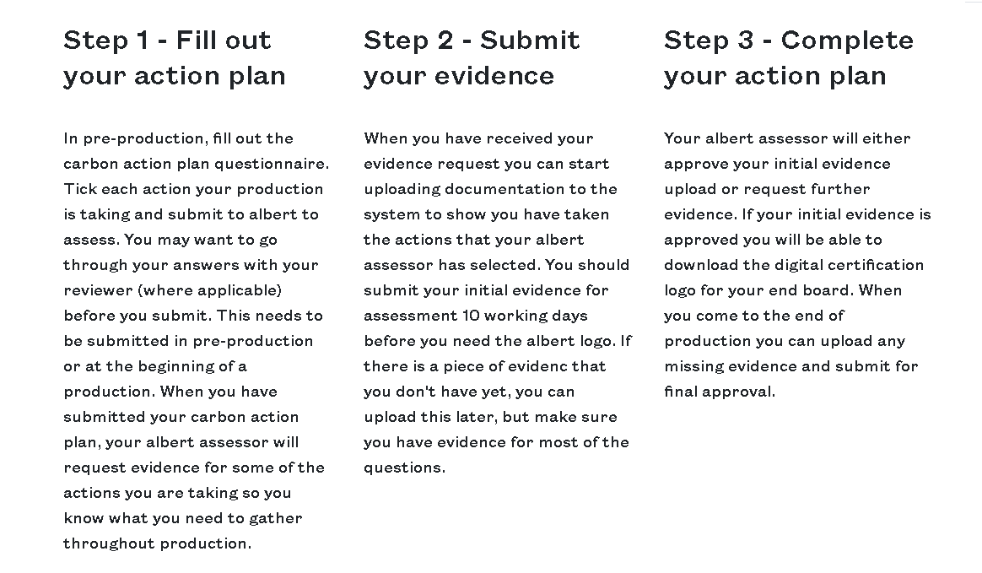

See below questions you will be asked as part of the action plan, and make notes here regarding the plan and evidence:
COMMUNICATION & ENGAGEMENT | Y/N | PLAN/EVIDENCE
Is there a senior person accountable for implementing agreed sustainable goals (i.e. HOP, PE, Producer)?
Will the results of an albert carbon footprint draft been used to inform the production’s environmental goals?
Have any of the production staff or crew attended or will attend the albert training?
Will everyone on the production (i.e., cast, onscreen, HOD's, crew) be sent a 'green memo' prior to filming, to make them aware of the production's environmental goals? (Minimum once annually for continuing programmes)
Are the production's environmental goals routinely discussed at production meetings?
Is the production asking all suppliers to contribute to the production's carbon reduction?
Will an albert final carbon footprint be completed at the end of production?
Will the production request and give feedback on sustainable production initiatives to cast, crew, suppliers and the production company? (For example, distributing a final green memo)
Will the production create audience or industry facing comms about the production's approach to sustainability?
Will the production make note of any costs incurred or savings made as a result of implementing environmentally positive actions?
EDITORIAL CONTENT (Planet Placement)
Is positive environmental behaviour featured in the dialogue of the programme?
Are there any props, background or actions items that have a link to sustainable living displayed on-screen
How have you ensured that any substantial components of this programme are not normalising unsustainable behaviour? Please send this question to a senior member of the editorial team to answer.
PRODUCTION ENERGY, MATERIAL AND WASTE
Is the production using a production office?
Are there measures in place to reduce the environmental impact of your building? (LED lights, lighting sensors, visual reminders on energy savings and waste management, etc)
Is mains power in production used from a 100% renewable sourced energy tariff?
Is there a zero-waste to landfill policy in your production office?
Are you filming in a studio?
Are there measures in place to reduce the environmental impact of your building? (LED lights, lighting sensors, visual reminders on energy savings and waste management, etc
Are you using lights on set?
Are you using low energy lighting to reduce the amount of energy needed?
Are you using mains power in studio?
Are you using mains power (no generators) as a primary power source in studio?
Is mains power used in studio from a 100% renewable sourced energy tariff?
Are you using generators in studio?
Have zero carbon generators been used? (e.g., waste vegetable oil generators, fuel cells or solar, electric generators)
Is there a zero-waste to landfill policy in studio?
Are you filming on location?
Are you using lights on location?
Are you using low energy lighting to reduce the amount of energy needed?
Are you using mains power on location?
Is mains power used in studio from a 100% renewable sourced energy tariff?
Are you using generators on location?
Have zero carbon generators been used? (e.g., waste vegetable oil generators, fuel cells or solar, electric generators)
Is there a zero-waste to landfill policy on location?
Is the production using post-production facilities?
Are there measures in place to reduce the environmental impact of your building? (LED lights, lighting sensors, visual reminders on energy savings and waste management, etc
Is mains power in post-production used from a 100% renewable sourced energy tariff?
Is the production using paper?
Does the production have an opt-in policy for paperwork to keep the amount of paper used to a minimum? (i.e., production documents, using online magazines, newspapers, emails etc)
Has the production used paper from a verified sustainable source? (e.g., FSC, PEFC, EU Ecolabel or any other paper made from recycled material)
Is the production using batteries?
Is the production using rechargeable batteries, including the sound department?
Is the production building sets?
Has the production used timber from a verified sustainable source? (e.g. FSC)
Is (or was) the original set constructed or dressed using recycled or pre-used materials?
Will the set build be donated, recycled or reused after the end of the production (i.e. not sent to landfill)?
Has the construction company and art department primarily used low VOC (volatile organic compound) or water-based paint?
Are you using props?
Are the majority of props rented or purchased second hand?
Are props re-used or disposed of sustainably (i.e. donated or recycled)?
Is the production hiring or purchasing any clothes and/or wardrobe accessories?
Is the costume department renting or reusing all items from other productions?
Is your costume department purchasing second-hand items, or new items with a sustainability standard (i.e. fair-trade, organic)?
Are costumes re-used or disposed of sustainably (i.e. donated or recycled)?
Are you using make-up?
As and when you replace your hair and make-up products, are you replacing with brands that support the environment as well as using reusable consumables
Are you using SFX?
Did you minimise the environmental impacts of any SFX? (i.e. biodegradable snow, reducing the amount of fuels used)
Are you using re-usable water bottles and/or cups for all cast and crew? (including dailies)
Are you asking your cast and crew to bring their own re-usable water bottles and/or cups if they have one?
Are you hiring a catering company for cast and crew?
Is food chosen with consideration for its environmental impact? (i.e. low carbon footprint and/or fair-trade, locally sourced, meat free days, etc)
Does the production only provide vegetarian and/or vegan meals?
Is the catering composting and recycling all food waste?
Has the catering eliminated all single use products?
Has the catering eliminated the use of plastic/polystyrene disposable products (e.g. cutlery, plates, cups) and are they using biodegradable materials that are composted or recycled?
Are you purchasing any food directly for the production? (excluding catering companies)
Are you prioritising restaurants/products with consideration for their environmental impact? (i.e. low carbon footprint and/or fair-trade, locally sourced, meat free days, etc)
Are you encouraging your crew to choose vegetarian or vegan options?
Have you eliminated single use products from all food purchased?
TRAVEL
Are phone or video-conferencing facilities being used in place of physical meetings?
Have you reduced and/or eliminate travel by using significant stock or archive footage to limit location filming?
Is all your crew local or within 50 miles of filming location? (exception for senior roles)
Are you paying for cast and crew travel?
Has the production reduced travel by sharing crew across more than one production?
Is the production shooting away from the main production base?
Has the production used significant local crew if shooting away from the main production base or city in order to reduce travel and accommodation costs?
Has the production hired or acquired equipment locally to reduce shipping or travel costs?
Does the production or any of its members need to travel more than 200 miles?
Has the production eliminated mainland domestic air travel?
Is anyone in the production travelling internationally?
Has the production reduced international air travel?
Are you hiring vehicles?
Based on location and journey type, has the production evaluated which will be the most efficient vehicle, and chosen the option with the smallest impact?
Are you using Couriers?
Have you chosen a courier company that only uses low-carbon emitting vehicles?
Are you exclusively using bicycle couriers (not motorcycles) for transport within inner-city areas?
Are you using taxis?
Have you chosen a taxi company that only uses low-carbon emitting vehicles? (i.e. hybrids, electrics)
Are you providing accommodation to any cast and/or crew?
Has the production chosen accommodation based on its environmental credentials or the impact it has on travel to location?
Does the accommodation use electricity from a 100% renewable energy source?
CARBON NEUTRAL PRODUCTION
To successfully complete a carbon action plan in the UK your production must be carbon neutral. If your production has not been commissioned in the UK you can still complete the carbon action plan and you can choose whether to offset the remaining emissions.
To achieve carbon neutrality you should decarbonise your production as much as possible through choosing renewable energy, electric transport etc. and then you will need to offset the rest. You can offset through albert or through another reputable offsetting project. Visit our offsetting page for more info.
Offsetting typically costs 0.1% of a production's budget but it's important that you complete a draft footprint so you know how much to budget for offsetting and the areas in which you might be able to reduce your impact.
Will the production offset its emissions (calculated from the albert calculator)?

